**Exercise No: 5**

**Date:14/10/2020**

**Aim:**

We aim to make a string Pangram i.e., printing the missing alphabets from the given sentence.

**Program:**

a = input("enter the input sentence: ")

a = set(a.strip())

a.remove(chr(32))

b = "abcdefghijklmnopqrstuvwxyz"

b = set(b)

b = b.difference(a)

b = list(b)

b.sort()

print("".join(b))

**Link:**

http://103.53.53.18/mod/vpl/view.php?id=235

**Output:**

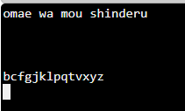

**Result:**

The program has been successfully executed and verified.